Supplement 6

Statistical Process Control

**Background**

Of all of the mathematical concepts presented in the text, SPC charts certainly rank among the most important to cover in an operations management course. Instructors who want to delve into some of the statistical background and who want to cover acceptance sampling could present Supplement 6 as rather challenging for business students. On the other hand, instructors who focus on the basics of the four SPC charts will find that most students can grasp the techniques rather handily.

It’s important to emphasize that control limits are not the same thing as engineering specification limits. Control limits are designed to *monitor* output over time to ensure that the system continues to produce consistent output. Output produced outside of control limits sends a signal that something extraordinary has occurred and the firm should investigate. One way to illustrate this in class is to bump into the projector in the middle of introducing control charts. Then point out that if you did not turn around periodically to look at the screen, you would never know that the slide is now projecting to the ceiling. So even though the equipment was set up perfectly at the beginning, we use control charts (turn around and look at our output) to periodically check to ensure that output still looks O.K. Spec limits, on the other hand, are fixed engineering measurements that define exactly what determines acceptable output or not. Any output produced outside of spec limits must be rejected. It is possible for output to exceed control limits and still be within spec limits. And, theoretically at least, it is possible for output that exceeds spec limits be appear to be within statistical control.

With SPC charts, students can get tripped up in several places. First, they must be able to choose the appropriate chart for the problem at hand. For variables (anything that can be measured along a number line such as length, temperature, volume, etc.), *both* and *R*-charts must be used. Figure S6.5 (and slides S6-35 and S6-36) show nicely why both are necessary. Choosing the correct chart for attributes (binary output such as percent defects) can be a bit tricky. The *p*-chart is used to monitor the *percentage* over time, while the *c*-chart is used to monitor the *number* of occurrences over time. But what if students are provided a set of number of errors over time as in Example S4, but without a “Fraction Defective” column? The answer is that they should convert those numbers to percentages and use a *p*-chart. What’s the difference? A *p­-*chart is used for output that has a specific sample size. A *c*-chart, on the other hand, has no sample size. A *c*-chart looks at an “event,” which has no practical upper limit on the number of occurrences. For example, students could make a *c*-chart to monitor the number of mistakes in the instructor’s lectures over time. The instructor could have one mistake in a day, or five, or ten, or...there’s really no upper limit. Hence, there is no sample size and it is impossible to convert the numbers into a comparable fraction from day to day.

Another potential area of confusion for students is mixing up sample size and number of samples, particularly for and *R*-charts, and especially if the data are presented with output from each sample going down the columns of a table instead of across the rows. Students sometimes also do not fully realize that -charts examine sample *averages*. So it is perfectly acceptable to have an *individual* product with output that exceeds the control limits as long as the *average* for that entire sample still lies within the limits (assuming, of course, that the individual item was still produced within spec limits). With *p*-charts, students sometimes enter the number of samples for *n* instead of the sample size, and they sometimes round too much within the square root sign for σ*p*. They should be told to generally use four decimal places, at least until after the square root function is applied. Finally, students sometimes are confused by the thought that a percent defects that is *below* the LCL is out of control. Here instructors can stress that control limits are pointing out *the unusual*, whether unusually good or unusually bad. If, say, a firm determined that no defects occurred on the day that the boss walked around the production floor, perhaps the boss should walk around the production floor more often.

If instructors cover process capability, this can be a place where the distinction between control limits and spec limits can be emphasized. It is probably worth covering the process capability ratio *Cp* in case students see it at their firms; however, the process capability index *Cpk* is the one that should be stressed. It is also easy to calculate but overcomes a major flaw with the *Cp* value.

Acceptance sampling calculations are rather complicated. They are skipped in this textbook and in most other introductory operations texts. Interested instructors can refer to Tutorial 2 on the website for more background.

**Class Discussion Ideas**

1. SPC is a set of rules designed to signal when there is a change in a process – to signal when assignable causes are likely to be present. Too often students focus on the math and fail to create a link to the actual process being measured. Select a set of processes the students will be familiar with and create control charts that show an out-of-control condition. Have the students identify possible assignable causes for each of the processes.

2. It can be a fun (if not, humbling) exercise to ask the students to help set up a *c*-chart to monitor the instructor’s mistakes during class from day to day. The students could identify the types of errors that would be counted as a mistake, as well as possible causes for those errors when the number of mistakes becomes out of control. An alternative exercise might set up a *c*-chart that would monitor the number of mistakes displayed in student oral presentations, which could include mistakes of content as well as presentation skills. Student-identified causes of poor presentations might be humorous.

**Active Classroom Learning Exercises**

1. Dice Game for Statistical Process Control. See Other Supplementary Material below.

2. Perhaps the most common mistake students make when working SPC problems is to confuse sample size and number of samples. Set up some simple sampling exercises and have the students identify both values. This seems to work best when the instructor is careful to avoid using either phrase in his or her description of the processes.

3. Deming, W. Edwards. 1986. Deming's Experiment. *Out of the Crisis*. MIT Center for Advanced Engineering Studies, Cambridge, MA 346-354. This activity is a substantial variation on the glass bead. It is used to illustrate the impact of variation which exists within a system and the extent to which that variation limits the effectiveness with which individuals can be evaluated. After seeing that the variation in the proportion of red beads is similar to that in the proportion of defectives, the students should recognize that system variation should be a primary focus of attention rather than individual efforts.

**Company Videos**

1. *Frito-Lay’s Quality-Controlled Potato Chips (10:15)*

Frito-Lay is committed to quality in four key areas: (1) quality ingredients, (2) strict adherence to recipes, (3) adherence to all process parameters, and (4) twice per shift inspections that mimic consumer inspections (bag appearance, snack taste, etc.). Continuous improvement is the heart of the firm’s quality assurance program. Frito-Lay focuses on two key metrics: (1) customer complaints per million bags, and (2) hitting the center line on SPC charts for various attributes such as oil content, moisture, seasoning, salt, thickness, and weight. The plant has nine critical checkpoints in the production process, which are all shown in the video. A significant portion of the video includes a thorough explanation of SPC charts, including an example of how to produce an *x*-bar chart, with a known population standard deviation, for the percent salt content in potato chips. The video then shows us how the operator at Frito-Lay produces an SPC chart observation, from scooping the samples to measuring the salt content to updating the chart. At Frito-Lay, action is taken whenever the SPC chart displays the following: (1) an observation outside the 3σ control limits, (2) two consecutive observations very near either control limit, (3) five consecutive observations that trend in the same direction, or (4) five consecutive observations that fall on the same side of the mean. “Star Fleet” teams are available from other plants to help individual plants solve some of their more difficult production problems. All of these practices contribute to Frito-Lay’s whopping 60% market share.

Prior to showing the video, the instructor might ask the students to guess how many and what types of inspections occur at a plant that makes potato chips. Afterwards, the nine types of inspection shown in the video, in addition to the “twice per shift consumer-like inspection” and the in-store inspections, could be compared to the student guesses. Further discussion could attempt to see if students understand the difference between inspection and statistical process control. In particular, “control limits” are not the same as “specification limits.” A sample that fails an SPC test would not necessarily be rejected as being an unsuitable product. SPC is an ongoing exercise that is looking for unusual circumstances or some sort of shift/wear in the production process so that the process can be corrected quickly and before serious output problems emerge. In other words, failure of an SPC test would not necessarily cause a full shutdown of the line or the rejection of an entire production lot.

2. *Farm to Fork: Quality at Darden Restaurants (12:14)*

The primary theme of this video is that Darden works to ensure quality at the *source* (i.e., “farm to fork,” “dirt to door,” or “pond to plate”), rather than inspecting for quality once the product arrives at local restaurants. Darden sources much of its food, including 50 million pounds of seafood annually, from Asia and Latin America. The firm employs 50 microbiologists, food scientists, and public health professionals. Inspections teams are located in China, Singapore, Thailand, Ecuador, Chile, and Honduras. In fact, such detailed source inspection results in the need for only a few domestic verification labs. Darden uses most of the total quality tools described in the text, including SPC charts, Pareto charts, flow diagrams, fishbone diagrams, and scatter charts. Within SPC, Darden primarily uses -charts, *R*-charts, and capability histograms. These charts monitor items like the thickness and weight of steaks and the thickness and length of salmon. An example is provided showing a process that appears to be in control, but the lot would be rejected because the means show up on the capability histogram as being skewed on the low side. Vendors are aware that Darden conducts regular audits that are stricter than FDA standards. Darden provides extensive education for vendors around the world to show them how to prevent contamination and take samples of product. The firm will visit farms to inspect and train, and also to check sanitation and personal hygiene conditions. Darden takes temperatures of fish throughout the entire supply chain journey, including right before it is served to the customer. All of these approaches to quality assurance helped Darden to win the prestigious Black Pearl Award for quality in the food industry.

Prior to showing the video, instructors might ask the students to consider what type of inspections that they expect for the food served in their favorite restaurant, and at what point in the process they would expect those inspections to take place. Discussion following the video could cover some of these initial impressions. Students might be surprised to know that Darden conducts so many inspections before the products leave the respective countries of origin. Such a program clearly involves a great deal of resources. Students could be asked to identify the pros and cons of such an approach of attempting to ensure quality at the source. Instructors could then ask if this approach makes sense in every industry, or is there something special about food that makes quality at the source particularly important? Clearly not all manufacturing firms today are conducting such extensive testing at their overseas suppliers. Can students identify examples from the news that have described recent quality problems from overseas suppliers?

**Cinematic Ticklers**

1. *The Simpsons, Season 4: “Duffless,”20th Century Fox Video, 2004 (1992-1993)*

Homer visits a Duff beer plant where the inspector pulls out beer bottles containing syringes and rats, but fails to catch Hitler’s head rushing by on the conveyor belt because he was talking to a customer.

**Presentation Slides**

INTRODUCTION (S6-1 through S6-5)

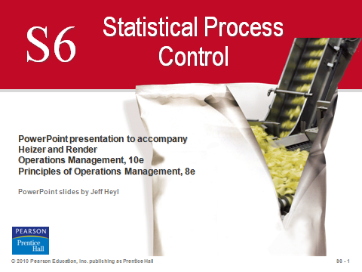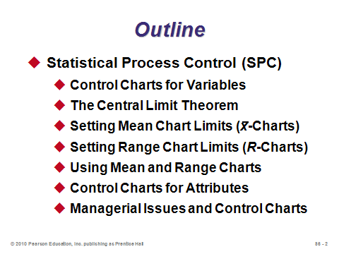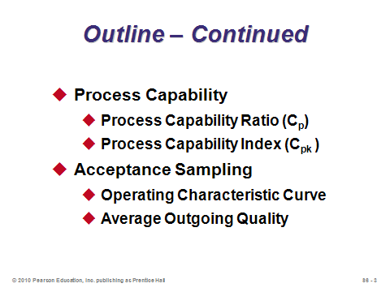

**S6-1 S6-2 S6-3**

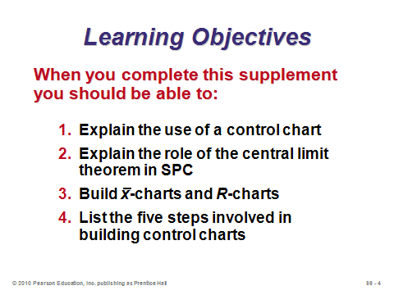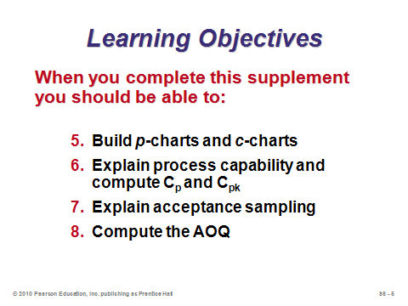

**S6-4 S6-5**

STATISTICAL PROCESS CONTROL (SPC) (S6-6 through S6-55)

Introductory Subsection (S6-6 through S6-16)

Slides 6-9: Here instructors can discuss the idea that variation occurs all the time. We expect it and plan for it. A basketball player, for example, may have a good shooting percentage one night but a poor one the next night. We use control charts, however, to try to determine when the variation is so far beyond the norm that we think it is likely caused by something extraordinary. For example, the basketball player may have been sick on the day that she shot 10% from the floor, or she might have been eaten a granola bar before the game on the day that she shot 90%. In the latter case, she might try to eat a granola bar prior to subsequent games to see if that should become her new pre-game routine.

Slides 10-14: These all come from Figure S6.1, which describes the important steps in determining process variation. Managers are trying to determine of the shape of the sample output over time remains stable (Slide 13) or varies (Slide 14). If it varies, we say that the process is out of control and investigate to take possible corrective action.

Slide 15: The book covers four different charts, but no matter which is being used, the concept is always the same. That is, output is monitored and if it falls above or below the control limits, the firm investigates for assignable causes.

Slide 16: The difference between control limits and spec limits can be discussed here.

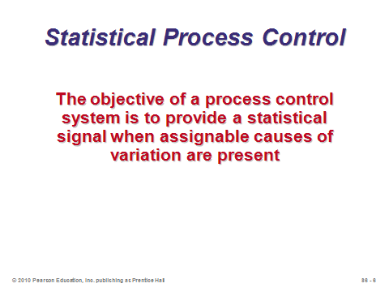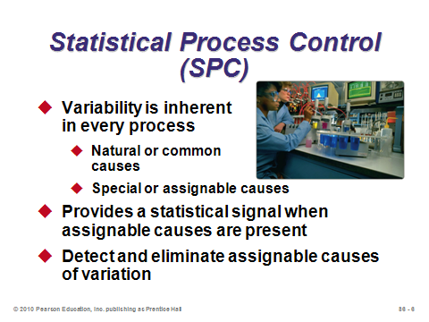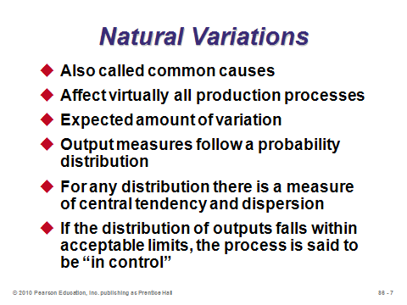

**S6-6 S6-7 S6-8**

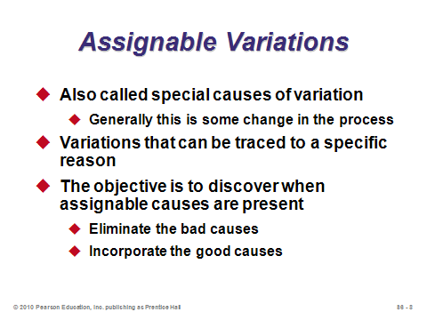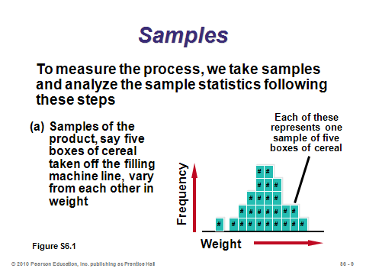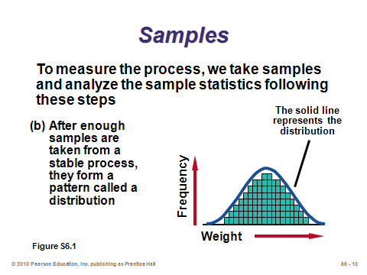

**S6-9 S6-10 S6-11**

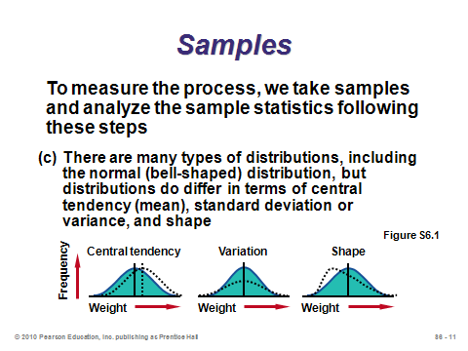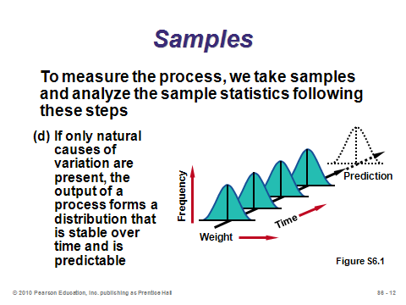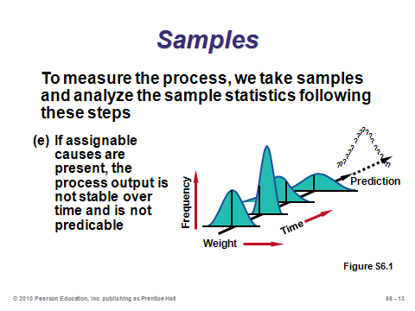

**S6-12 S6-13 S6-14**

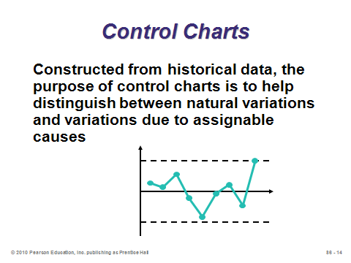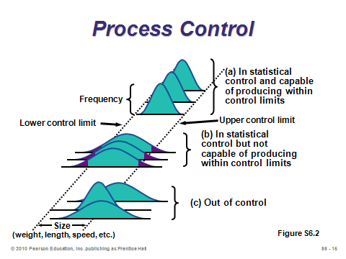

**S6-15 S6-16**

Control Charts for Variables (S6-17 and S6-21)

Slides 17&21: Variables vs. attributes are introduced here. The instructor should fill in with some examples of each and at this point mention that *and* *R-*charts are used for variables while *p*-charts *or* *c*-charts are used for attributes.

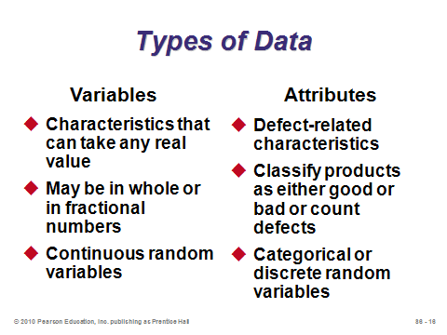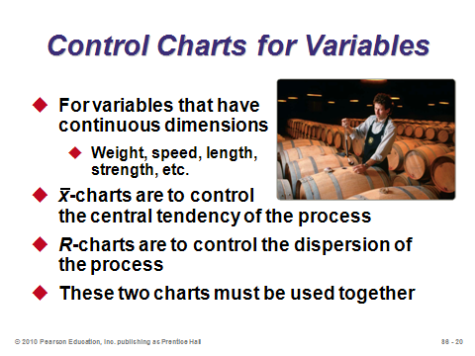

**S6-17 S6-21**

The Central Limit Theorem (S6-18 through S6-20)

Slides 18-20: These provide statistical foundation for control chart theory.

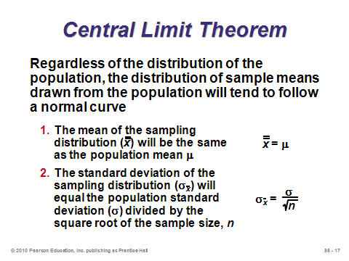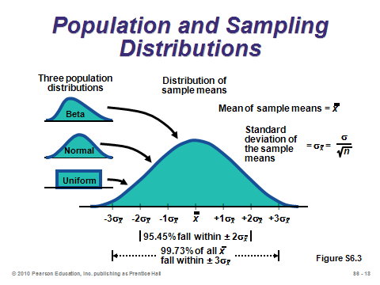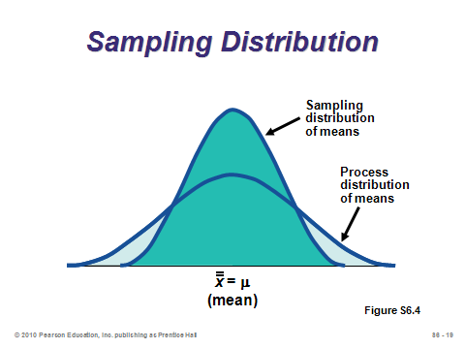

**S6-18 S6-19 S6-20**

Setting Mean Chart Limits (-Charts) (S6-22 through S6-31)

Slides 22-24: This is the first numerical example shown in the slides, and it is applied for -charts when the process standard deviation is known. At this point instructors should discuss the implementation of the *z*-value. The most common practice is to draw limits at three standard deviations from the mean (*z* = 3), but any other *z*-value is possible. The manager must make a trade-off between Type I and Type II errors. The higher the *z­*-value, the more likely it is that assignable causes of variation will go undetected, while the lower the *z*-value, the more likely it is that natural causes will mistakenly be designated as assignable. Slide 24 nicely illustrates why the process in this example is out of control.

Slides 25-29: This example shows the formulas and an application for -charts when the process standard deviation is not known. Table S6.1 (Slide 26) is used in this case, and is based on a *z*-value of three. Instructors could point out that the limits for -charts are equidistant from the mean.

Slides 30-31: These are based on Example S2, and show real SPC graphs used by Darden restaurants. These also appear in the video case study. (Note that at this point in the supplement, process capability (Slide 31) has not been covered yet.)

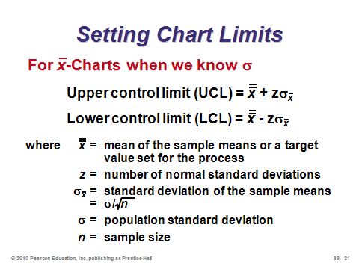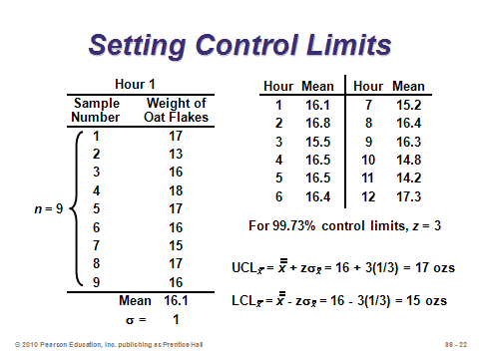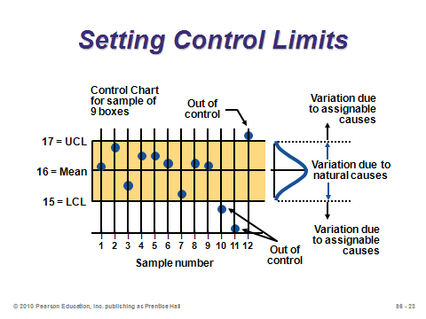

**S6-22 S6-23 S6-24**

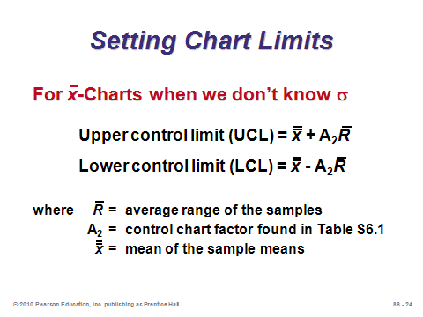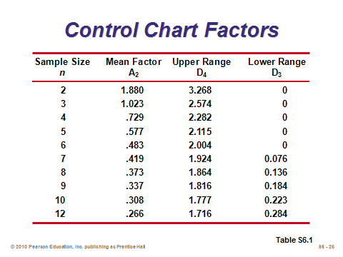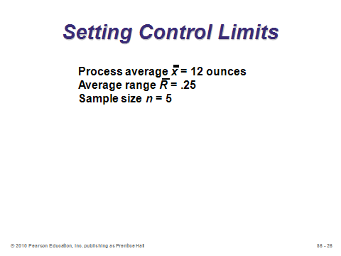

**S6-25 S6-26 S6-27**

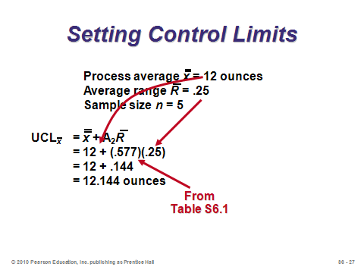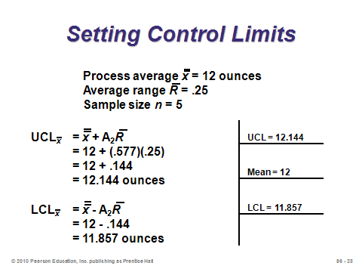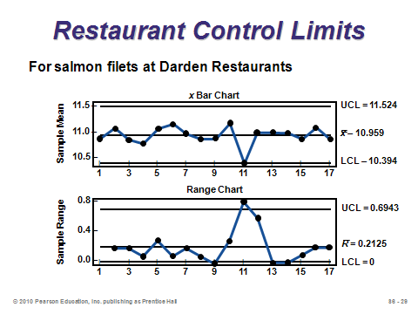

**S6-28 S6-29 S6-30**

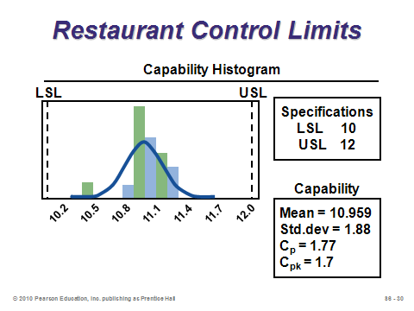

**S6-31**

Setting Range Chart Limits (*R*-Charts) (S6-32 through S6-34)

Slides 32-34: This example shows the formulas and an application for *R-*charts. Again Table S6.1 (Slide 26) is used. Instructors can point out that the range (highest value minus the lowest value in a sample) is used as a proxy for the standard deviation. Also, for small enough sample sizes, the LCL for the range chart will be zero, suggesting that it is impossible to have and unusually small amount of dispersion for samples that small.

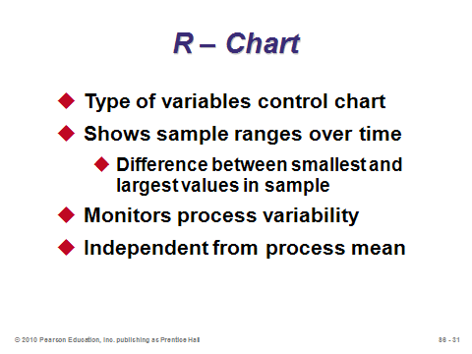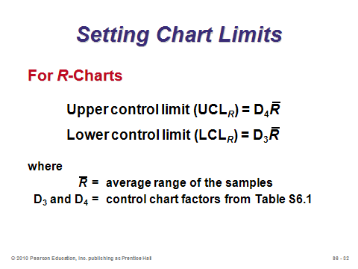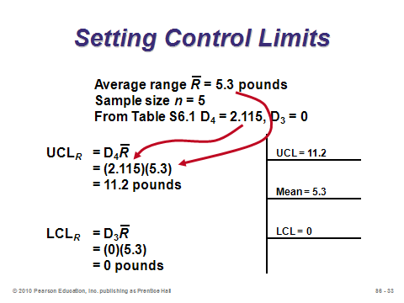

**S6-32 S6-33 S6-34**

Using Mean and Range Charts (S6-35 through S6-38)

Slides 35-36: These come from Figure S6.5. They nicely illustrate why firms must monitor *both* the and *R*-charts when monitoring variables. (In fact, the *R*-chart should come first, because if the process variability is not in control, then the  formulas are not valid because the formulas incorporate variability information.)

Slides 37-38: In a short break from the examples, these two slides summarize the control chart process for any type of chart (Slide 37) and provide an illustration of both manual charting and computer-generated charting (Slide 38).

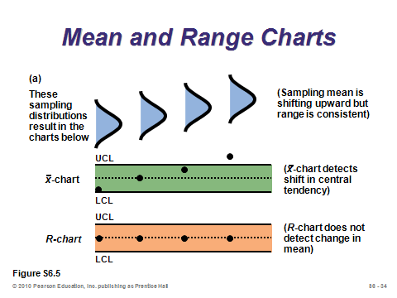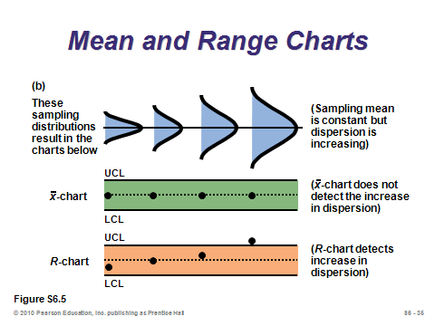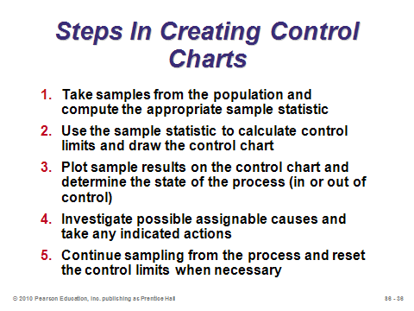

**S6-35 S6-36 S6-37**

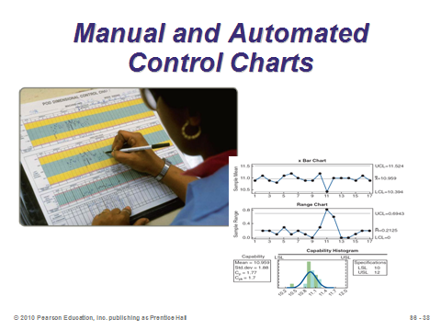

**S6-38**

Control Charts for Attributes (S6-39 through S6-45)

Slide 39: Here is where the difference between *p*-charts and *c*-charts should be emphasized. As stated above in “Lecture Design Ideas,” the typical determining factor should be whether or not each sample has a sample size: if so, use a *p*-chart, if not, use a *c*-chart.

Slides 40-43: This example shows the formulas and an application for *p*-charts. The default value for *z* should be 3, but that does not always have to be the case. Instructors should point out on Slide 41 that the sample size is 100, and *n* = 100 is not always the case. Also, is calculated in a streamlined way on Slide 41. Students should note that this approach is quicker and safer than summing up all of the *pi* values with decimal points and then taking an average. Slide 42 puts shows the LCL limit as 0 for this example. Here, students should see that a negative LCL calculation is possible, and that it is just rounded up to zero in practice.

Slides 44-45: This example shows the formula and an application for *c*-charts. It comes from Example 5 in the text. The *c*-chart limits are the easiest to calculate and don’t require any sample size information. For this example, the example suggests that the process is in control.

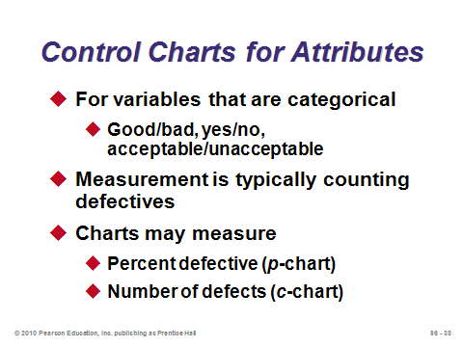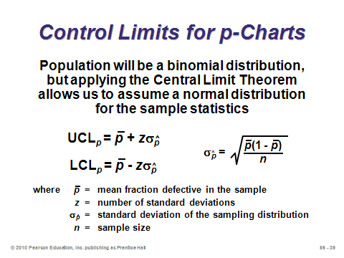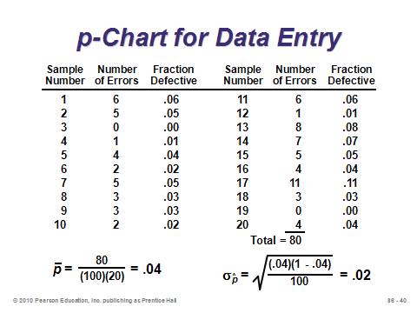

**S6-39 S6-40 S6-41**

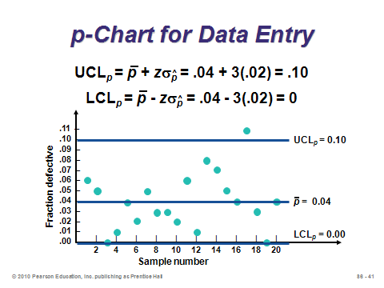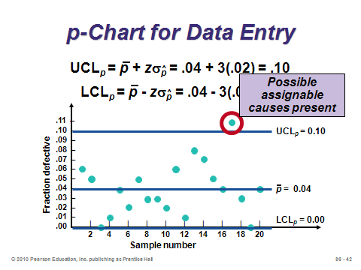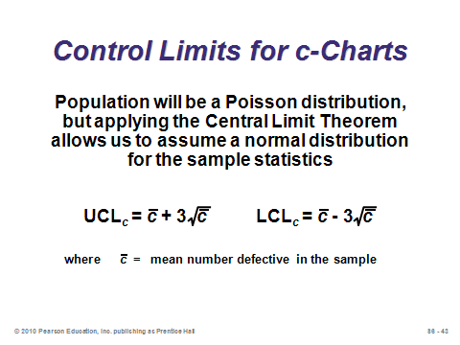

**S6-42 S6-43 S6-44**

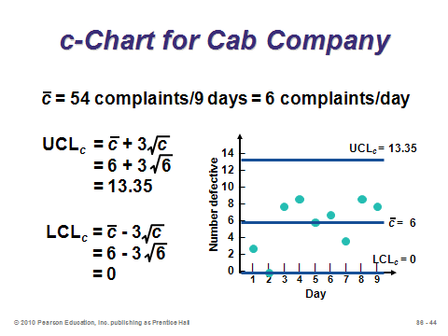

**S6-45**

Managerial Issues and Control Charts (S6-46 through S6-55)

Slides 46-49: These summarize the control charting process, as well as determining which chart to use.

Slides 50-55: The basic control chart decision rule is to investigate for assignable cause once any point lies beyond the control limits. And, actually, this decision can easily be made by looking at the output data and comparing to the control limits—an actual chart does not have to be drawn. There are more subtle signaling techniques, however, that process control professionals recommend, and four of these are shown in Slides 52-55. An actual graph of the output becomes particularly useful when looking for patterns like these.

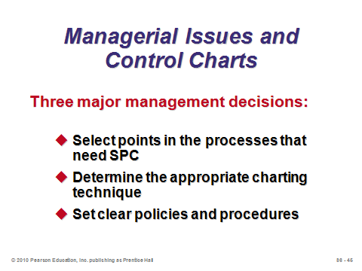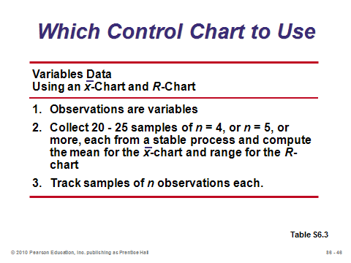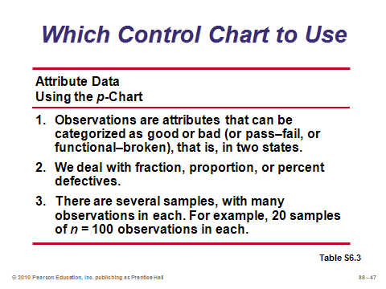

**S6-46 S6-47 S6-48**

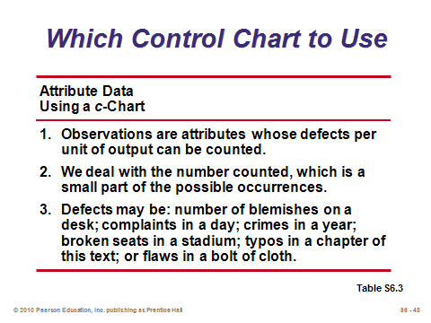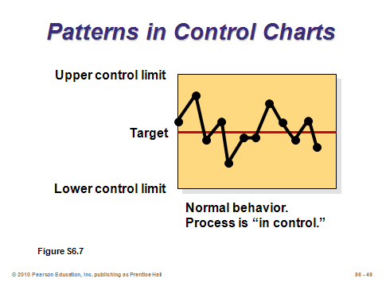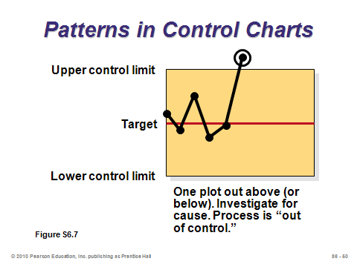

**S6-49 S6-50 S6-51**

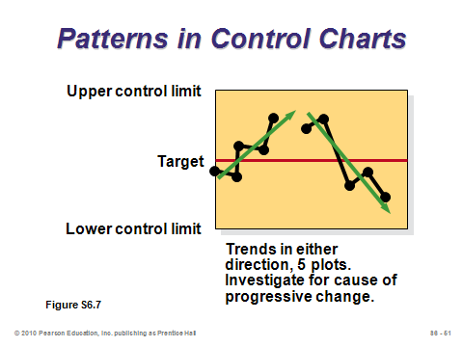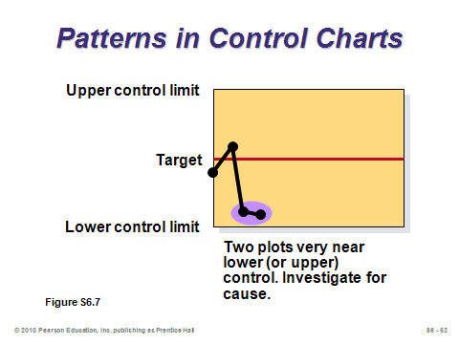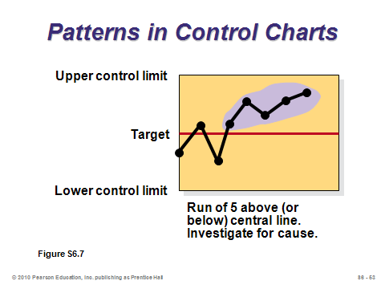

**S6-52 S6-53 S6-54**

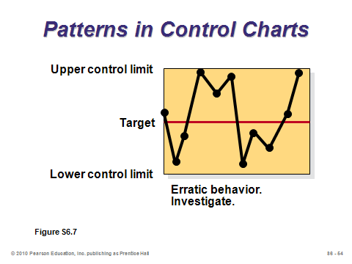

**S6-55**

PROCESS CAPABILITY (S6-56 through S6-65)

Slide 56: Capability charts deal with spec limits, not control limits, and they more commonly occur at the design stage to see if a process is capable of producing within limits most of the time (“most” usually means 99.73%). A process deemed “incapable” needs a design fix, which may be more severe than correcting an assignable cause as occurs with control chart violations.

Slides 57-60: These slides provide the formula and an example for the process capability ratio *Cp*. The biggest danger in making decisions based on *Cp* is that the ratio cannot detect a process that is not centered. Thus, it may signal a process as “capable” that is consistently producing output above or below the target.

Slides 61-65: These slides provide the formula and an example for the process capability index *Cpk*. This measure is generally preferable to *Cp* because it does a better job of signaling “capability” on both sides of the mean, thus better picking up a the effects of a skewed distribution.

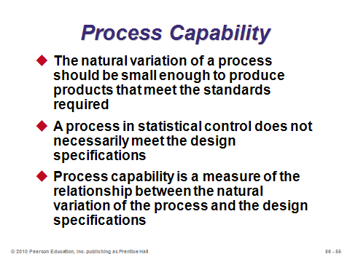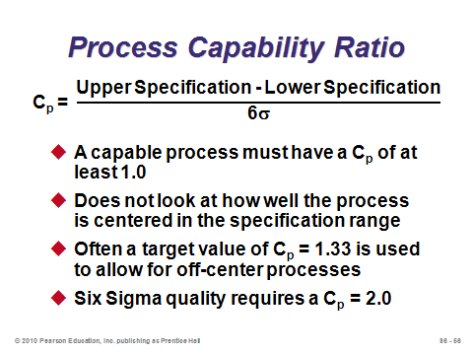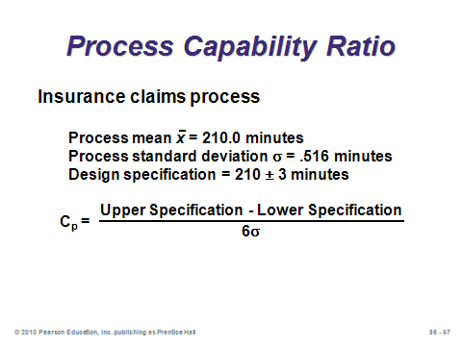

**S6-56 S6-57 S6-58**

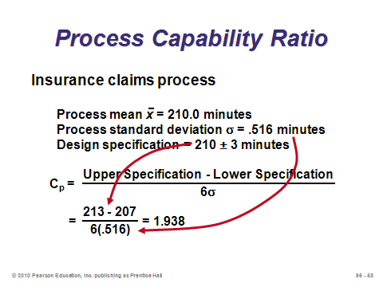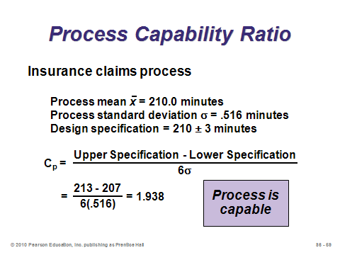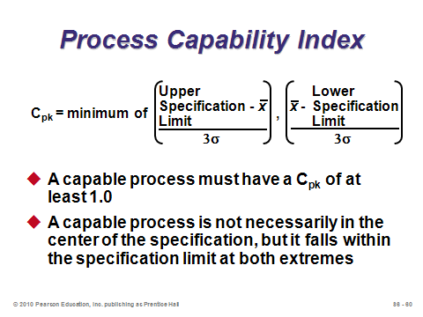

**S6-59 S6-60 S6-61**

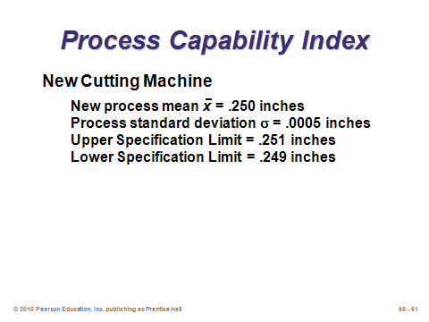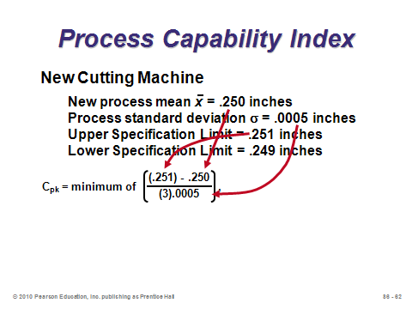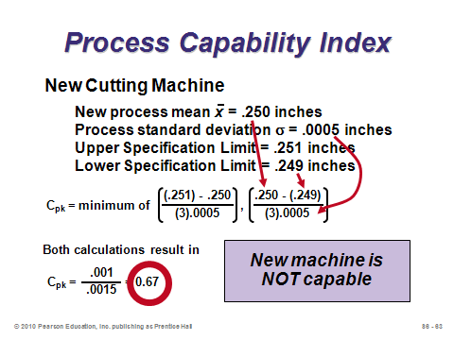

**S6-62 S6-63 S6-64**

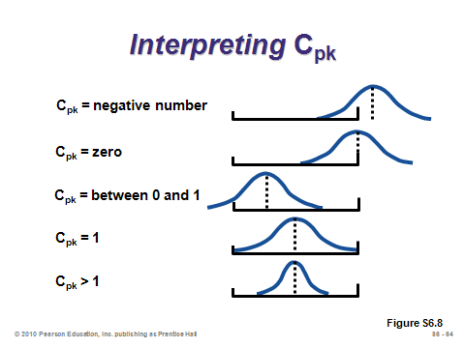

**S6-65**

ACCEPTANCE SAMPLING (S6-66 through S6-77)

Slides 66-67: Capability studies focus on whether or not a process is capable of producing within specs under normal circumstances; control charts monitor output over time to make sure that something unusual hasn’t occurred; while inspection itself determines whether completed items themselves are acceptable or not. Firms practice acceptance sampling to avoid having to inspect every single incoming or finished goods item. It is assumed that the defect rate of the sample is reflective of the defective rate of the entire lot.

Slides 68-75: The text cannot devote enough space to show how to compute everything needed to draw an operating characteristic curve, so these slides just describe the concepts. The average outgoing quality can be computed (Slide 74) if (1) the sampling plan replaces all defective items encountered, and (2) the true incoming percent defective for the lot is known.

Slide 76: Certain automated inspection plans have eliminated the need for acceptance sampling.

Slide 77: The final slide can be used to summarize the three major methods introduced in this supplement.

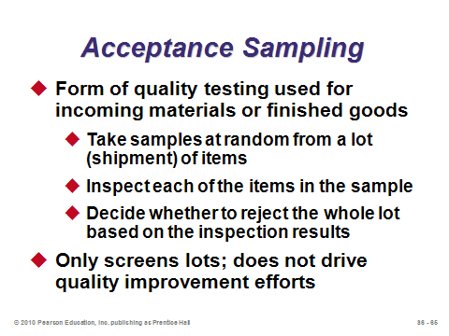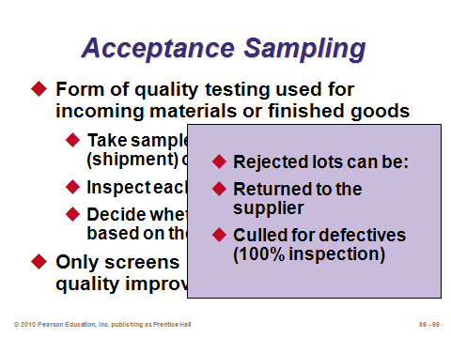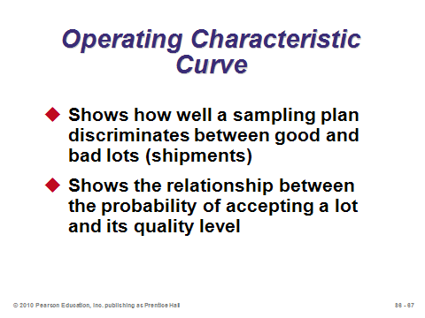

**S6-66 S6-67 S6-68**

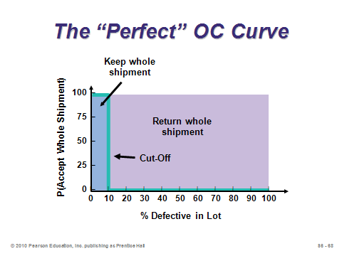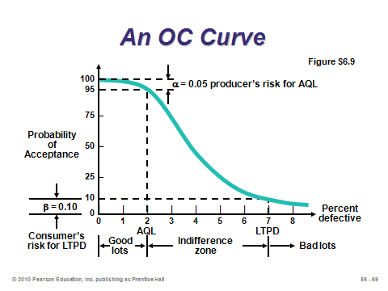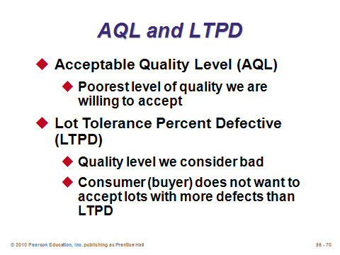

**S6-69 S6-70 S6-71**

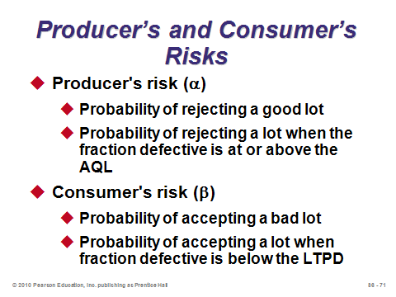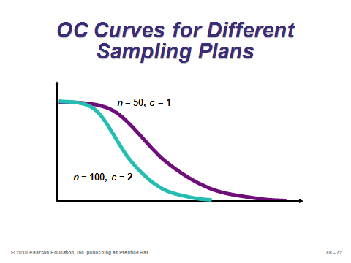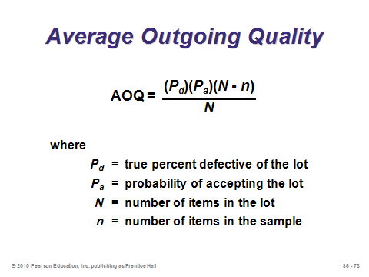

**S6-72 S6-73 S6-74**

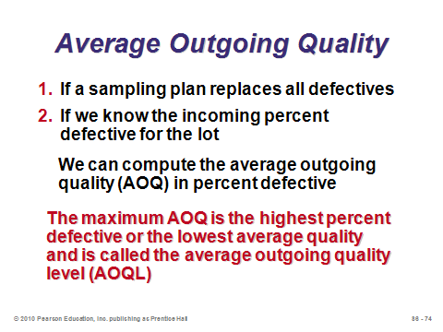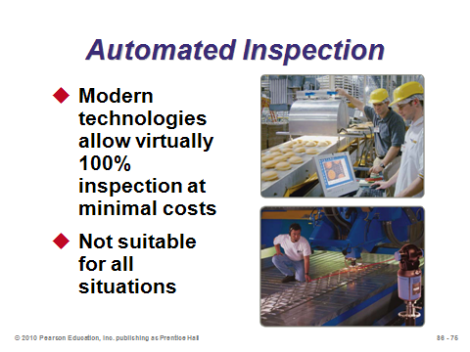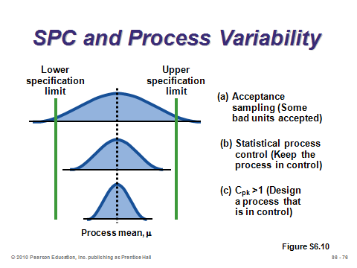

**S6-75 S6-76 S6-77**

**Additional Assignment Ideas**

1. Visit the Web page of a company that markets SPC software. Explore their software product. Print out examples that show the variety of charts that can be created and explain their use. What types of services are offered by these companies to help implement SPC? (Hint: search for one of these products or any other product or service of your choice: "Qualitran" or "SAS" or "DataLyzer".)

**Additional Case Studies**

Internet Case Study (www.pearsonhighered.com/heizer)

* *Green River Chemical Company*: Involves a company that needs to set up a control chart to monitor sulfate content because of customer complaints.

Harvard Case Studies (http://harvardbusinessonline.hbsp.harvard.edu)

* *Deutsche Allgemeinversicherung* (#696-084): A German insurance company tries to adopt p-charts to a variety of services it performs.
* *Process Control at Polaroid (A)* (#696-047): This film-production plant moves from traditional QC inspection to worker-based SPC charts.

Richard Ivey School of Business (http://cases.ivey.uwo.ca/cases/pages/home.aspx)

* *Blount Canada Ltd.—Continuous Improvement (A)* (#9A92D013): This case provides background about the company and presents a completed QI story about the problem of defective products being shipped to a customer. The QI story identifies one department as the worst “internal vendor”. Students are asked to take the role of the supervisor of that department and decide what to do.

**Internet Resources**

|  |  |
| --- | --- |
| American Society for Quality | www.asq.org |
| American Statistical Association | www.amstat.org |
| Associated Quality Consultants | www.quality.org |
| Business Process Improvement | spcforexcel.com |
| Institute of Statistics and Decision Sciences at Duke University | www.isds.duke.edu |
| Statistical Engineering Division of the Department of Commerce | www.itl.nist.gov/div898 |
| Total Quality Engineering | www.tqe.com |

**Other Supplementary Material**

Videos

Films available from:

Society of Manufacturing Engineers

One SME Drive

P.O. Box 930

Dearborn, Michigan 48121-0930

(P) 313-425-3000

(F) 313-425-3412

http://www.sme.org

* *The Cost of Poor Quality--Case studies in Merix Corp., IBM, and Copeland Corp.* show successful strategies for reducing poor quality costs. Order # PI-VT570-3456
* *Factory Data Collection*-See how Hayes Industrial Granke, Modem Plastics Molding, S & W Screw Products, and Tandem Computers handle data collection. Order # PI-VT287-3456
* *Linking Measurements to the Machine*--Case studies show how manufacturers implement this technology and how they benefit. Order # PI-VT514-3456

Learning Games

* Price, B. and Zhang, X. (2007). The Power of Doing: A Learning Exercise that Brings the Central Limit Theorem to Life. *Decision Sciences Journal of Innovative Education*, 5(2), 405-411. Teaching brief that demonstrates an active learning technique for teaching the Central Limit Theorem. Groups of students conduct experiments tossing a die in a set of 5 rolls (or 10 rolls). Students are asked to calculate sample average.
* Fish, L. (2007). Statistical Quality Control: Developing Student’s Understanding of Variable Control Charts using String. *Decision Sciences Journal of Innovative Education*, 5(1), 191-196. Teaching brief offers a mini-demonstration for variable control charting.
* Reyes, P.M. (2006). Using a Rubber Band to Teach the Management of Quality. *Decision Sciences Journal of Innovative Education*, 4(1), 123-128. Teaching brief that helps students understand measurement system analysis and its effects on process improvement using a simple two-phase hands-on gage of repeatability and reproducibility (GR&R) study.
* Wright, C and Smith, M. (2003). Serving Up the Red Beads Experience. *Decision Sciences Journal of Innovative Education*, 1(1), 127-131. Teaching brief useful when teaching quality management, statistical process control, and the management of people within a manufacturing setting. Uses an airplane example and incorporates many of the principles from Deming’s 14 Points.
* LaPoint, Gary. Dice Game for Statistical Process Control. (see below)

**Teaching Note**

**Dice Game for Statistical Process Control**

Gary LaPoint, School of Management, Syracuse University

This exercise works best after a normal lecture on statistical process control. It does an excellent job of getting the students to understand the mechanics of the process. The difference in student understanding of SPC with this exercise and without the exercise is significant.

**Length:** Approximately 45 minutes

**Material needed:** (1) A pair of dice for each team. (Usually available at the local Dollar Store or hobby shop.); (2)Work template (see following pages.)

**Exercise:** Organize the class into teams of two. Give each team a pair of dice and a work template.One student rolls the pair of dice while the other records the number on the template. Take 10 samples with a sample size of 4. (This requires rolling the dice 40 times.)

Then have students calculate the *X*-bar, the Range, *X*-double bar, and the *R*-bar.

When students have completed the above, have them then calculate the UCL and LCL for *X*-bar and *R* charts. (I have them calculate the Upper and Lower control limits using Table S6.1 in the text.) Students cannot manually calculate the upper and lower control limits using the formula because they do not have the standard deviation of the dice rolling process. Although if you do the calculation, the standard deviation is 2.297.

Have the students develop the *X*-bar and *R* charts (you can provide the templates that follow or have the students prepare them themselves). Once the students have created their graphs, ask them if their process is in control.

Then give them upper and lower tolerance limits as defined by the customer that are lower than the process control limits they calculated, say 7.5 and 4. Following that discussion, ask them to determine the Cpk Index, and decide if the process is capable of operating within those tolerances. Several teams will not be capable. Then collect the students’ charts and go over them on an overhead so the entire class can see different types of process.

Finally, ask what is inherently wrong with the exercise. The sharp students will say we can only get a value between 2 and 12, which is correct. Therefore, this exercise is not perfect in simulating random variation.

On the following pages are instructions to the students and the required tables and graphs for creating the data set and control charts.

**Dice Game for Statistical Process Control**

**Student Instructions**

1. Take 10 samples of sample size 4. (Roll the dice 40 times)
2. Calculate the *X*-bar and the Range for each sample
3. Calculate the *X*-double bar and the *R-*bar.
4. Calculate the UCL and the LCL for the *X-*bar and the *R* chart.
5. Plot the values for each sample.
6. Is the process in control?
7. Given the upper and lower tolerances desired by the customer, is the process in control?
8. Using the Cp*k* index, is the process capable of operating within those tolerances?

**Record of Observations**

|  |  |  |  |  |  |  |
| --- | --- | --- | --- | --- | --- | --- |
| Sample Number | 1 | 2 | 3 | 4 | *X*-bar | *R* |
| 1 |  |  |  |  |  |  |
| 2 |  |  |  |  |  |  |
| 3 |  |  |  |  |  |  |
| 4 |  |  |  |  |  |  |
| 5 |  |  |  |  |  |  |
| 6 |  |  |  |  |  |  |
| 7 |  |  |  |  |  |  |
| 8 |  |  |  |  |  |  |
| 9 |  |  |  |  |  |  |
| 10 |  |  |  |  |  |  |
| Average | | | | |  |  |

UCL*R* = UCL*X*-bar =

LCL*R* = LCL*X*-bar =

Cpk =

***R*-Chart**

|  |  |  |  |  |  |  |  |  |  |
| --- | --- | --- | --- | --- | --- | --- | --- | --- | --- |
|  |  |  |  |  |  |  |  |  |  |
|  |  |  |  |  |  |  |  |  |  |
|  |  |  |  |  |  |  |  |  |  |
|  |  |  |  |  |  |  |  |  |  |
|  |  |  |  |  |  |  |  |  |  |
|  |  |  |  |  |  |  |  |  |  |
|  |  |  |  |  |  |  |  |  |  |
|  |  |  |  |  |  |  |  |  |  |
|  |  |  |  |  |  |  |  |  |  |
|  |  |  |  |  |  |  |  |  |  |
|  |  |  |  |  |  |  |  |  |  |
|  |  |  |  |  |  |  |  |  |  |
|  |  |  |  |  |  |  |  |  |  |
|  |  |  |  |  |  |  |  |  |  |
|  |  |  |  |  |  |  |  |  |  |
|  |  |  |  |  |  |  |  |  |  |
| 1 | 2 | 3 | 4 | 5 | 6 | 7 | 8 | 9 | 10 |
| Samples | | | | | | | | | |

***X*-bar Chart**

|  |  |  |  |  |  |  |  |  |  |
| --- | --- | --- | --- | --- | --- | --- | --- | --- | --- |
|  |  |  |  |  |  |  |  |  |  |
|  |  |  |  |  |  |  |  |  |  |
|  |  |  |  |  |  |  |  |  |  |
|  |  |  |  |  |  |  |  |  |  |
|  |  |  |  |  |  |  |  |  |  |
|  |  |  |  |  |  |  |  |  |  |
|  |  |  |  |  |  |  |  |  |  |
|  |  |  |  |  |  |  |  |  |  |
|  |  |  |  |  |  |  |  |  |  |
|  |  |  |  |  |  |  |  |  |  |
|  |  |  |  |  |  |  |  |  |  |
|  |  |  |  |  |  |  |  |  |  |
|  |  |  |  |  |  |  |  |  |  |
|  |  |  |  |  |  |  |  |  |  |
|  |  |  |  |  |  |  |  |  |  |
|  |  |  |  |  |  |  |  |  |  |
| 1 | 2 | 3 | 4 | 5 | 6 | 7 | 8 | 9 | 10 |
| Samples | | | | | | | | | |